Math 1 Name_______________________________

**2-3 Intro to Function Notation Practice** Date________

* *I can interpret function notation and explain how the output of a function is matched to its input.*
* *I can interpret the meaning of an ordered pair*

1. Evaluate the following expressions given the functions below:



|  |  |
| --- | --- |
| Solve | Ordered Pair(s) |
| a. *g*(5) = |  |
| b. *f*(3) = |  |
| c. *h*(-4) = |  |
| d. *j*(3) = |  |
| e. *h*(-2.5) = |  |
| f. *g*(-1) = |  |
| g. *f*(-3) = |  |
| h. *h*(4) = |  |
| i. *j*(0) = |  |
| j. If *g(x)* = 10, what is *x*? |  |
| k. If *h(x)* = -20, what is *x*? |  |
| l. If *f(x)* = 20, what is *x*? |  |

Can you find *h(c)* = ?

Can you find *g(m + n)* = ?

1. Write the following coordinate points in function notation:
2. (5, 20) b. (-4, 18) c. (-20, -1) d. (-6, 0)
3. Given the graph of *b(x)*: Find:
4. 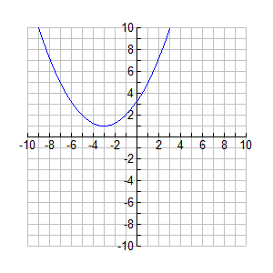 *b*(-3) = _______
5. *b*(-5) = ________
6. *b*(2) = ________
7. If *b(x)* = 5, what is *x*?